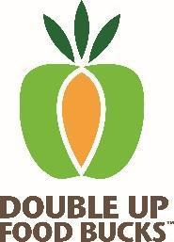
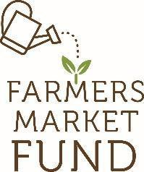
Double Up Food Bucks
Letter to Eligible Produce Vendors

Dear Produce Seller,
Hillsboro Farmers’ Markets has received a grant from Farmers Market Fund, a nonprofit based in Portland, to offer a program that doubles the amount of money that SNAP recipients can spend to purchase fruits and vegetables. This program has the potential to increase your income and expand our market’s customer base.
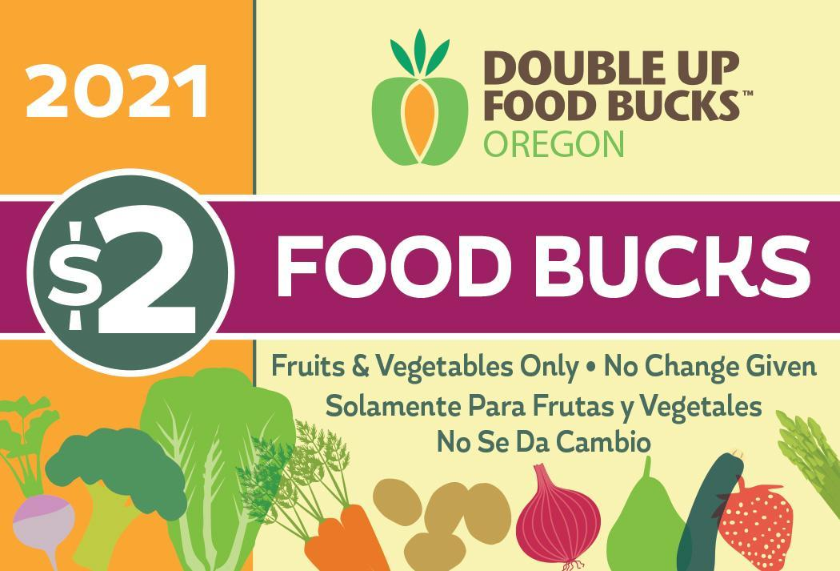
SNAP card users can double their benefits up to $10 per market day and receive Double Up Food Bucks to be used only for fruits and vegetables. The DUFB-branded matching currency – similar to the size and feel of a playing card, are worth $2 each, and can only be used to purchase fruits and vegetables that meet the following criteria:
• GOOD FOR: any variety of fresh, dried, or frozen whole or cut fruits and vegetables without added sugars, fats, oils, or salt. Includes mushrooms, fresh herbs, nuts, dried beans, and edible plant starts/seeds.
• NOT GOOD FOR: grains, meat, eggs, cheese, baked goods, prepared foods, fermented foods, salsa, pickles, jams, jellies, honey, cider, juice, tea, or other foods that do not fit into the above guidelines; nonfood items.

As a seller of produce, you are invited to participate in this program! To be able to accept DUFB, you must sign and return the attached Vendor Acknowledgment form, confirming you understand the program rules.
DUFB currency should be turned in at the same times you turn in your SNAP EBT tokens, and the market will reimburse you for both. DUFB is active at over 50 locations in Oregon. Customers may spend DUFB at any participating market. For more information about the program, refer to the attached vendor FAQ.
Please complete and sign the attached Vendor Acknowledgment form and turn it in to the market manager as soon as possible. A signed acknowledgment must be on file with our market prior to accepting any Double Up Food Bucks from customers or turning in DUFB for redemption.
If you have any questions about this program, please feel free to contact the market manager.
Sincerely,

Liz Connor
Market Manager, Hillsboro Farmers’ Markets

